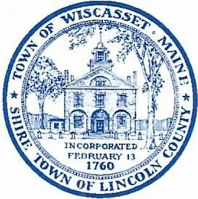
Town of Wiscasset

WINTER PARKING POLICY

In accordance with the Town of Wiscasset Ordinance Article IX, Sections 3.10 and 3.15 the Wiscasset Selectboard hereby adopts the following Winter Parking Ban:

Article IX section 3.15 prohibits the parking of “…any horse, carriage or motor vehicle within the limits of any street, road or way in the Town of Wiscasset in such a manner that the same shall in any way interfere with or hinder the removal of snow by mechanical or hand means from the street, roads, ways or sidewalks with said town…” and authorizes a Selectman or any police officer to tow said vehicle so interfering to a safe place at the owner’s expense. To enhance the efficiency of snow removal, in accordance with Article IX Section 3.10 which permits the Selectboard to “…fix the permitted hours of parking in all public parking areas…” the Selectboard adopts the following provisions: The Public Works Director may, at his discretion and after consultation with the Police Chief and Town Manager, issue a Winter Parking Ban on all or select ways within the Town of Wiscasset, and fix the hours of said ban based on the needs of the Public Works Department to efficiently clear snow. During this time, it will be unlawful for the operator or owner to cause, allow or permit any vehicle to be parked on any street within the Town of Wiscasset for a period of time longer than 30 minutes. Municipal parking lots may be utilized during parking bans. Any vehicle parked in a municipal lot as a result of a parking ban must be moved following the expiration of the declared ban, (or as soon as practical) unless the owner or operator of said vehicle is conducting business. The town may, at the owner’s expense, tow any vehicle which has not been removed. Bonafide emergency calls are exempt.

Notice of a Winter Parking Ban may be advertised on the local TV news stations, posted on the Town’s Facebook page, website and on the Community Sign, as well as sent via the TextMyGov app.

Penalties for illegal parking include a notice with a fine of $20 plus the cost of towing and impoundment.

If you have any questions regarding the Town’s Winter Parking Ban, please call the Wiscasset Police Department at 882-8202

Amended Dec 5, 2023 by a vote of the Wiscasset Select Board

_____________________________
Sarah Whitfield, Chair

